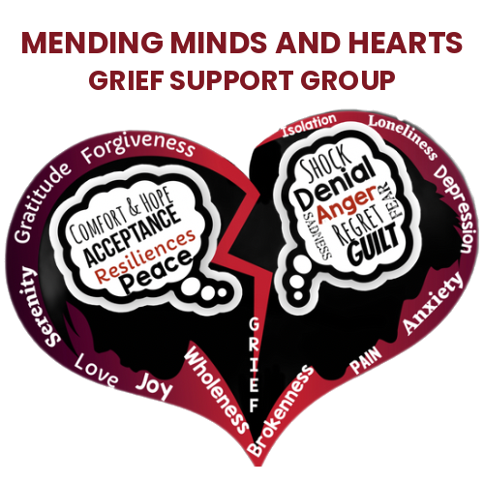
MENDING MINDS AND HEARTS
G R I E F S U P P O R T G R O U P
A 501(c)(3) Nonprofit Organization · Jersey City, NJ
www.mendingmindsandheartsjc.org · MendingMindsandHeartsJC@gmail.com · 201-680-8515
To a decision-maker who cares about this community,
If this letter is in your hands, it's because someone on your team believes in what we do — and thought you might too. We're honored by that.
Mending Minds and Hearts Grief Support Group is a 501(c)(3) nonprofit in Jersey City providing free grief support gatherings, workshops, and community events for individuals and families navigating loss. Founded on lived experience, our mission is simple: no one should have to grieve alone.
We are currently welcoming sponsors for our work and our first annual Gift of Life Fundraiser (August 13, 2026, at The Factory in Jersey City). Sponsorships range from $500 to $5,000, each with meaningful recognition for your organization — on our website, at our events, in our programs, and across our social media — and every dollar keeps our services free for grieving families.
Everything you need is at www.mendingmindsandheartsjc.org — sponsorship tiers, secure giving options, and our organization one-pager. Sponsorships are tax-deductible as allowed by law, and we provide written acknowledgment for every gift.
If a five-minute conversation would help, I'd be glad to have it — and to thank you personally on behalf of the families your support would reach.
With gratitude,
Laneisha Trent
CEO and Founder, Mending Minds and Hearts Grief Support Group
MendingMindsandHeartsJC@gmail.com · 201-680-8515 · www.mendingmindsandheartsjc.org
To the friend who passed this along — thank you. You are part of the healing.

